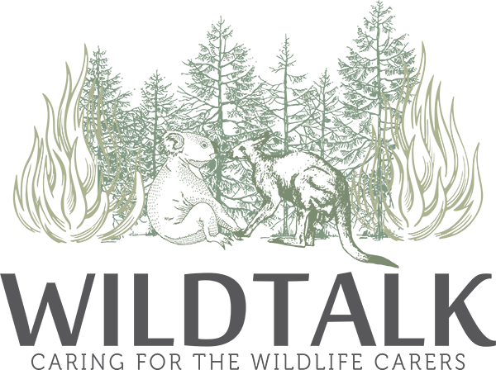
Wildtalk Selfcare
Are you a wildlife carer? Do you struggle to take time out just for you?
While caring for wildlife can be incredibly rewarding, it can also take a toll on physical, emotional and mental wellbeing. Wildtalk Selfcare is a 6-week program in which you will:
- Learn some practical ways to replenish yourself and enhance your well-being
- Experience some movement-based approaches to self-care through connecting body and mind
- Explore some of your experiences as a wildlife carer in a safe and supportive environment
Cost: $60 ($10 per session)
When: Mondays, 10-11 (in-person) /2-3 (via Zoom) commencing Monday 28 March 2022.
Where: Grant Cameron Centre, 27 Mulley Street, Holder, ACT or online via Zoom.
Further information: If you would like to know more about this program, please contact Hilary on 0477 844 562 or email: hilaryaberthon@gmail.com.
Registration is essential.
Facilitators:
Roni Ramirez Esquival. Roni in an experienced counsellor, ecopsychotherapist and member of the Australian Counselling Association. They are passionate about acknowledging and exploring the connection between mind, body and nature; and how these relationships can impact our lives, especially for wildlife carers.
Hilary Berthon. Hilary has over a decade of experience facilitating community groups and exercise classes and is certified to deliver Time Out Tai Chi. She is a Level 3 AUSactive Registered Professional and a Student Member of the Australian Counselling Association.

